BEGINNING STEPS:

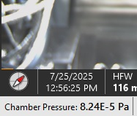
- Check chamber pressure in bottom left of main UI screen when microscope is at room temperature; log this number down

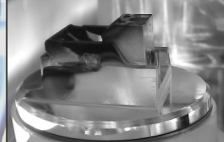
Shuttle

- Take shuttle out of the chamber
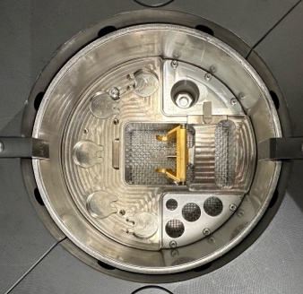
- Turn on green nitrogen gas tank that’s to the left of the prep pot & make sure the shuttle holder inside of prep pot is vertical and upright

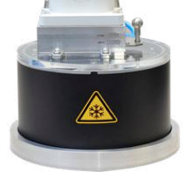
- Remove plastic plate on top of the prep pot, set aside & place transfer rod base on top of the prep pot

- Press “P” on the airlock transfer area, wait for gate valve click to be heard. Open gate valve, then open transfer rod valve if it’s not already open
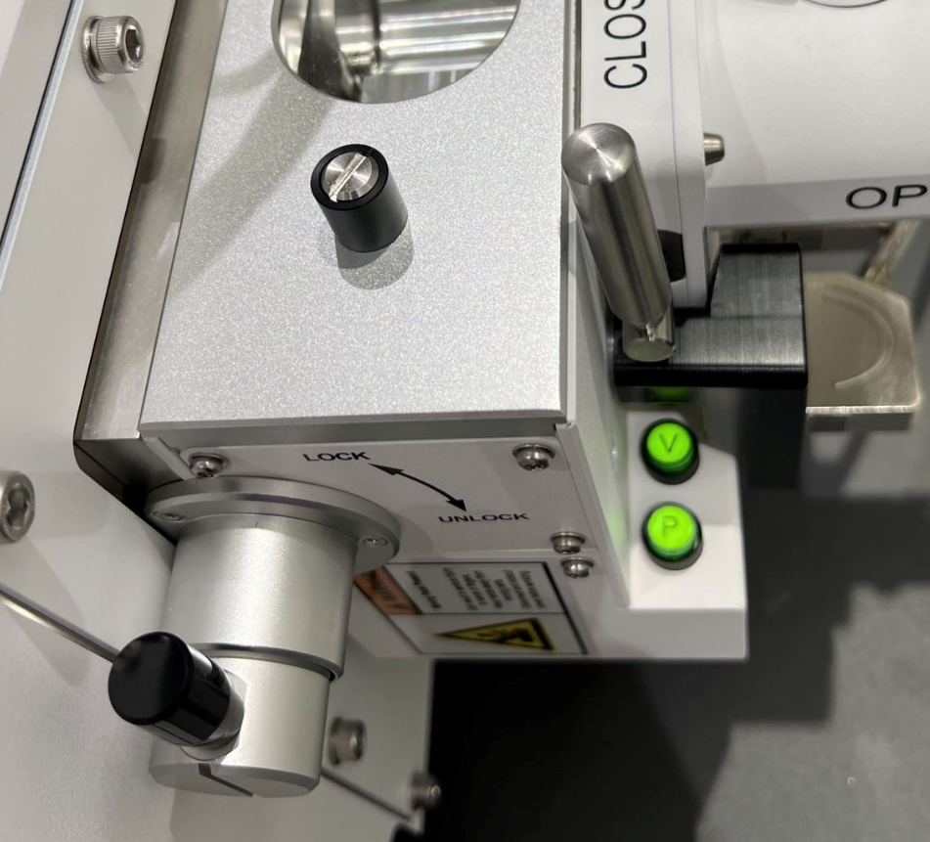
Transfer rod valve

V
P

Gate valve

- Unlock the rod by twisting the end of it, and slide the black knob to almost the end of the transfer rod sleeve, until you encounter a tiny bit of friction

- Lock the rod pin by twisting the black knob to the lock position & pull back on the black knob back the way you came, twist end of rod to the lock position

- Close the rod valve, close the gate valve

- When the “V” turns green on the airlock transfer area, press and hold for 1-2 seconds then un-tension the black clasps

- Place the transfer rod on top of the transfer base, & press “Pump” on the transfer base control panel, wait until the flashing light rapidly blinks

- When the flashing light happens, open the rod valve, then press “Vent” on the transfer base control panel, open the transfer base valve, twist end of transfer rod to unlock the rod, move rod down to shuttle holder inside of prep pot

- Twist black knob to unlock the rod pin, & move rod back up and twist end to lock in place

- Press “Pump” on transfer base control panel, remove transfer rod assembly and place to the left of the prep pot. Place plastic plate on top of prep pot

- “Vent” transfer rod off the transfer rod assembly; move transfer rod back to the airlock with clasps, open transfer rod valve

- Pump in UI by going to the sample exchange window and clicking “Pump” in the cryo-loader section
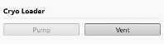
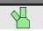
Sample exchange window opens when you double click this icon

FLOWING NITROGEN GAS:
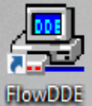
- On support PC, double click icon labeled “FlowDDE”

- Inside of “FlowDDE” Click on “Communication>Open communication” wait for dialogue to read “server is active and ready for any client”
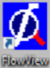
- Open up “FlowView”

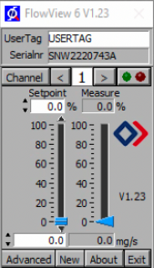
- Input “200” into the LEFT meter

200

- Go out of the Aquilos room to NS1.217
- Follow instructions taped to the outside of the left closet door
- Go back to the Aquilos room, you will have 200 flow reading in your RIGHT meter
- Start 30min timer
NITROGEN LEVEL IN LARGE DEWAR:
- If it needs to be filled, unplug the tiny fan cable that’s connected to the outside of the dewar
- (Cryo-gloves in white closet) Roll dewar over to NL to fill, full tank will take about 50min from close to empty
- Plug in fan cable when dewar is back
PURGING THE GIS:
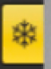
- In the middle monitor, find the “Cryo TEM preparation” tab

- Find the “Cryo GIS deposition” section & input 25 seconds into the “Flow Duration”
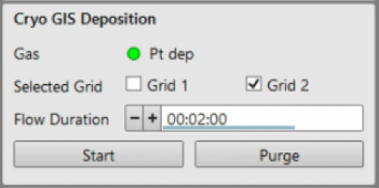
- Click on “Purge” in this same section, wait 25 seconds

SPUTTER COAT PURGING:
- Open sample exchange window to view your chamber vacuum tab
- Go to the “Cryo TEM preparation” tab

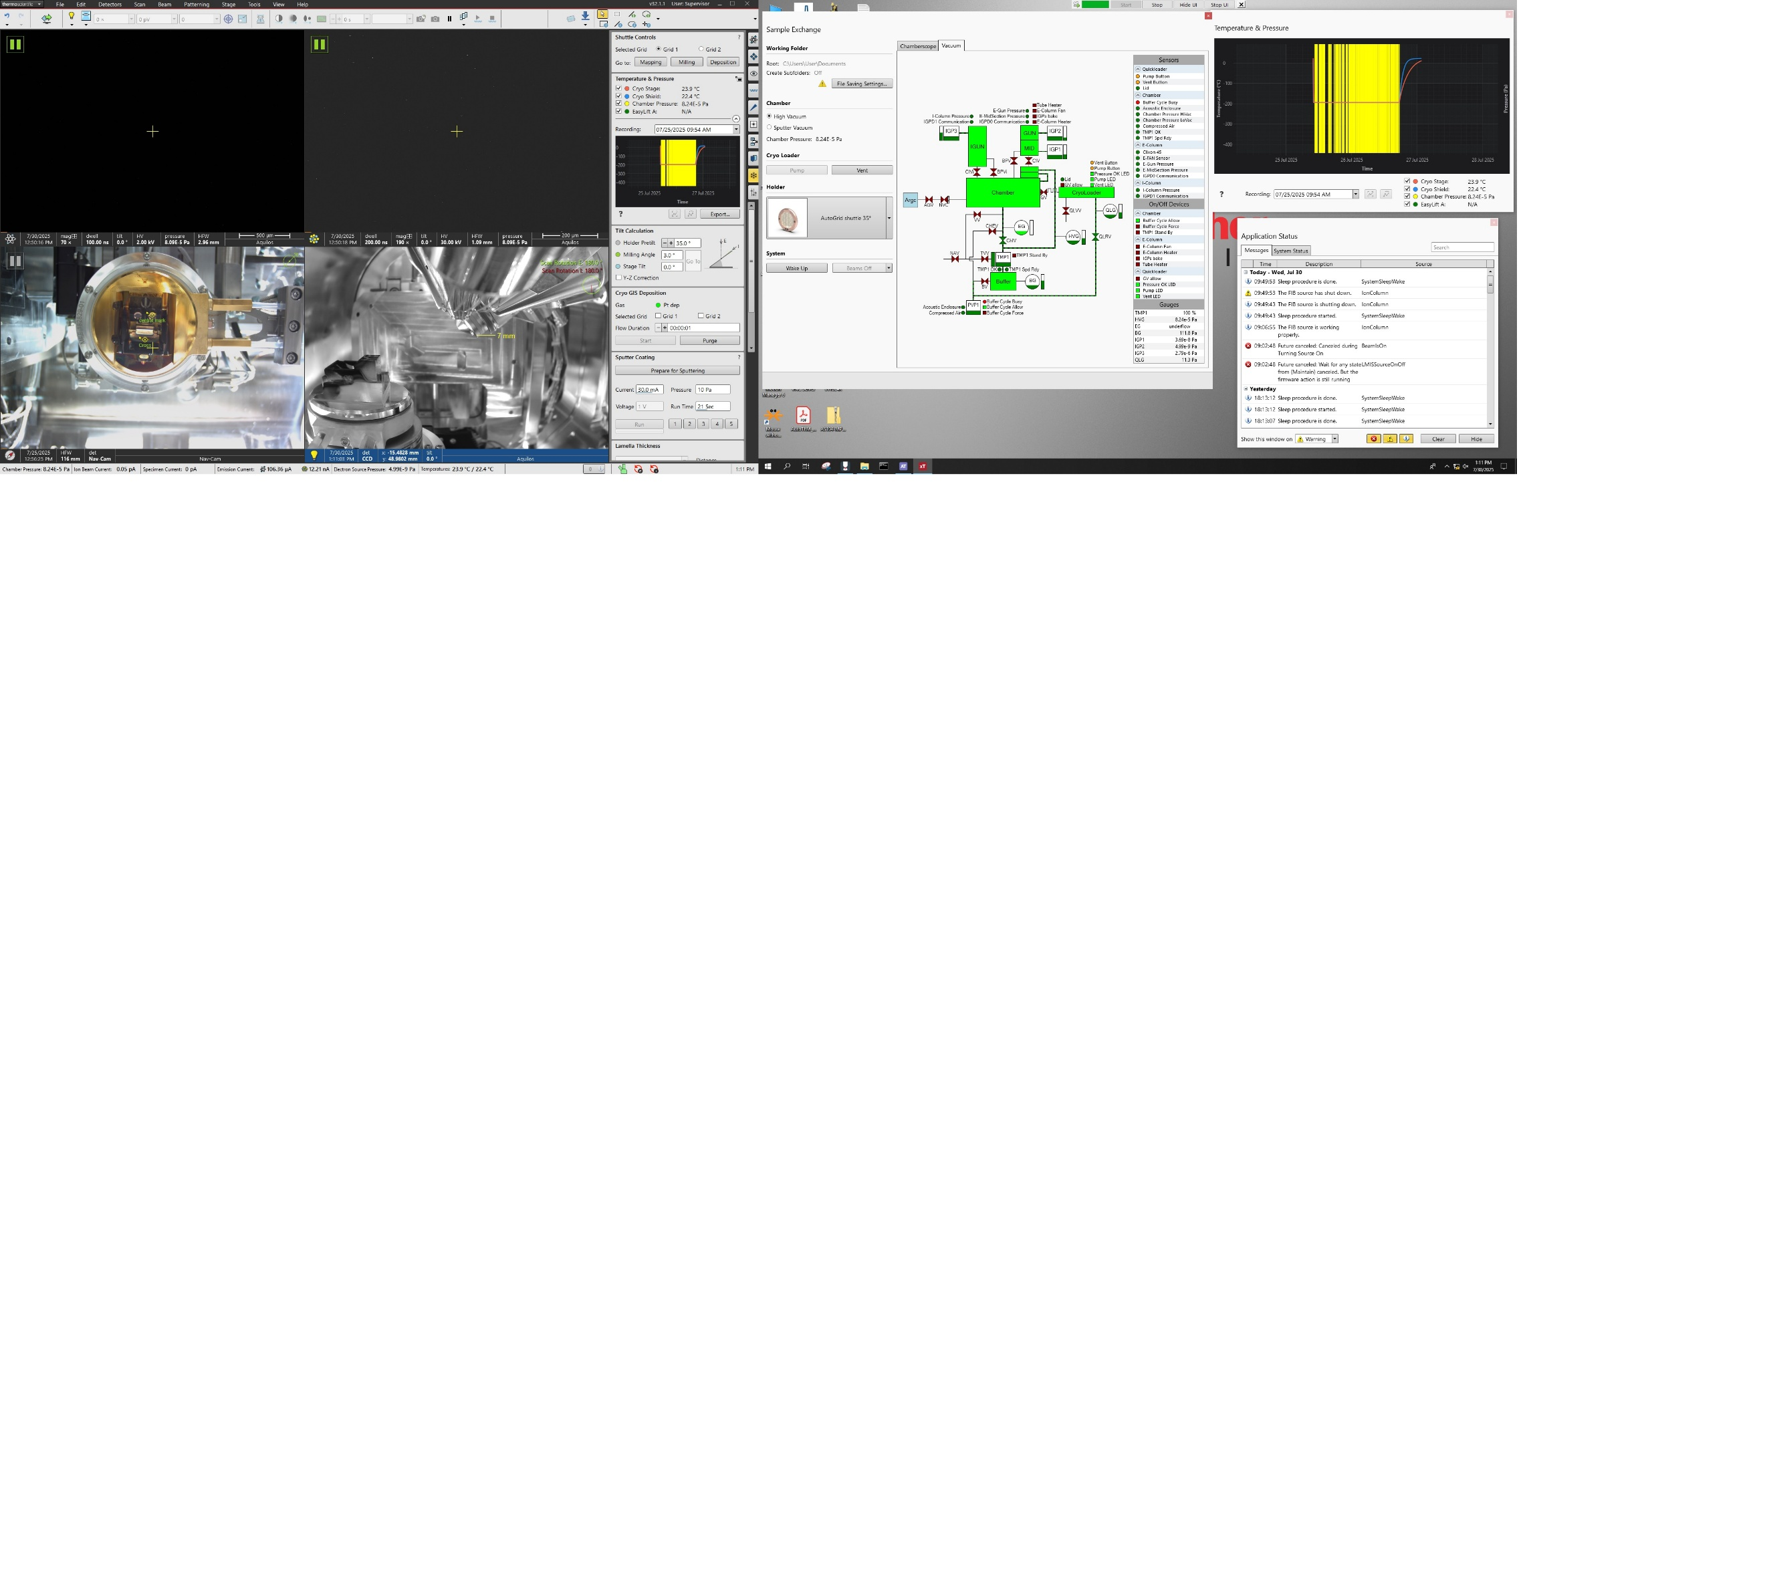
- Find the section “Sputter Coating”

- Preset number “1” should be labeled “beginning of day test” click on number “1”
- Parameters should be reading: Current: 30mA, Pressure 10Pa, Voltage 1V, Run Time 5 sec
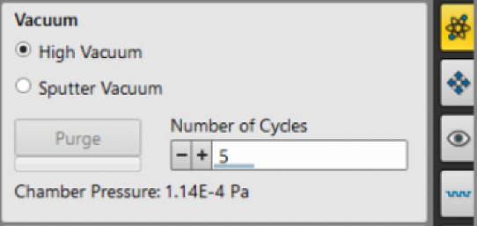
- Click “Prepare for Sputtering”, wait for chamber color to turn blue, then your stage will move into the sputter coating position (DON’T CLICK ANYTHING ELSE IN SOFTWARE UNTIL YOUR STAGE STOPS MOVING)
- Go to the “Beam Control” tab

- Input 3 cycles into “Number of Cycles” and click on Purge to the left

- Once chamber is blue, go to your “Cryo TEM preparation” tab and in the “Sputter coating” tab click on “Run”
- Wait for light to illuminate the stage, your stage will retract after it’s done
- Click on the previously labeled “Prepare for sputtering” which is now reading “Recover from sputtering”
- Wait for stage to move back to the previous position you had it in before you started (DON’T CLICK ANYTHING ELSE IN SOFTWARE UNTIL YOUR STAGE STOPS MOVING)
HOMING THE STAGE:
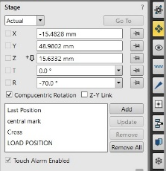
- Go to the top of the UI, find the “Stage” dropdown
- Click on “Home Stage” click on “Home Stage” again
- Wait coordinates to read “0” in your “Navigation” tab
- Click on “LOAD POSITION” then click “Go To”

COOLING THE SCOPE:
- Once the 30min timer is up, set the left flow number to “125”

125

- Take black styrofoam cap off large liquid nitrogen dewar, and place blue foam cap on dewar and slowly place cooling helix into the dewar
- Plug in copper plug to the hole on the blue cap & wait 2min
- Change flow rates to 250, wait for both stage and shield to be at -190°C then wait 10min
- Gradually change flow rates to 200, (240, 220, 200)
- Wait 10min, then start prep work to load sample

LOADING SAMPLES:
- Keep plastic plate on prep pot, but remove the lid and place funnel in either of the two holes on the left/right of the prep pot
- When filling the prep pot, start by filling in the middle section just until the top of the shuttle is covered by liquid nitrogen
- Fill in the outer section using funnel slowly
- Repeating steps 53,54 until boiling is done
- Fill middle section to prep pot to the fill line, DO NOT GO PAST THIS LINE
- Lock shuttle in place by screwing the gray shuttle lock using flathead screwdriver
- Load autogrids carbon side facing you and with autogrid notch as straight as possible
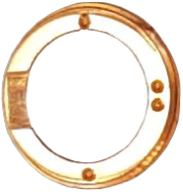
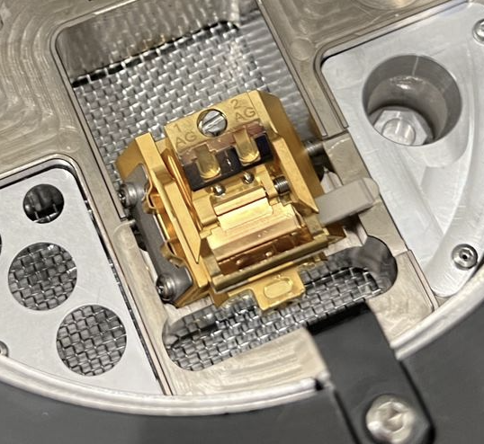
Gray shuttle lock
Flip shuttle

- Unlock shuttle and flip shuttle holder up using screwdriver in area indicated above
- Re-fill nitrogen to max fill line, place transfer base on prep pot, vent blank off transfer base and set aside
- Go to XTUI and log chamber pressure at cryo-conditions
- Go to airlock transfer area and close transfer rod valve, then hit “V” place transfer rod on transfer base which is attached to the prep pot
- Press “Pump” on transfer control panel, wait until light blinks rapidly, open transfer rod valve
- Press “Vent” on transfer control panel, open transfer base valve unlock rod by twisting the black end to unlock position, slide rod pin down into shuttle
- Lock rod pin on shuttle, pull back the rod, twist end to lock position, close transfer base valve
- Press “Pump” on transfer control panel, wait until light blinks rapidly, then close transfer rod valve
- Press “Vent” on transfer control panel, move transfer rod to airlock, tighten clasps on, press “P” for pump. Wait for gate valve click
- Open gate valve, open transfer rod valve
- Slide shuttle onto stage, and unlock rod pin, pull back rod and lock in place
- Close gate valve, place plastic plate on prep pot
- Go to XTUI to check samples

XTUI BEGINNINGS:
- Take Nav-cam photo. Top of UI, (Stage>Take Nav-Cam Photo), it will be set in the bottom left of XTUI
- Select E-beam quadrant. Top of UI, dropdown menu (Scan>Scan Rotation) select “180 °” Select I-beam quadrant, select "180 °”
- In your CCD quadrant (bottom right), you will have these two icons appear in the top right corner
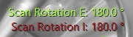

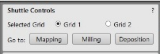
- Go to Cryo-TEM preparation tab, find section “Shuttle Controls” select either “Grid 1” or “Grid 2” go to “Mapping”

- Go to “Beam Control” tab

- Highlight E-beam quadrant, reset beam shift by going to the “Beam” section
- Right click in the “Beam Shift” area, click on “Zero”
- Repeat step 78 but with I-beam quadrant highlighted
- Find the “Column” section and with E-beam quadrant selected, click “Beam On”
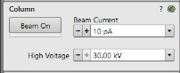

- Perform a quick scan at 2kv, 25pA to check if grid is centered, double click to move to center if needed, mag to 5000x and use reduced area (F7) to focus
- Focus using MUI (microscope user interface) and do stigmation if needed
- Mag out to lowest magnification, take photo (F2)
- Save image to designated folder
MAPS:
- Open Maps 3.29 by going to the top of the XTUI, to the top left dropdown menu in the XTUI that reads “thermoscientific”
- Once Maps 3.29 boots up, create project and save to the correct designated folder in the “E” drive on the microscope PC
- Re-name your layer in the left pane to whichever grid you are currently going to use.
- Can “Add Layer” next to “Add Tile Set” re-name the layer for grid 2 if you wish to add another grid to map
- Pull screenshot from E-beam into maps software by clicking the snapshot button in the top right row of buttons (camera icon)
- In the left pane, search for “TEMPLATE” drop-down menu
- Input “Evan_T” for a pre-set tile set, add it by the button directly to the left “Add tile set”
- Select the tile set by making sure it’s highlighted in the left pane then you can drag it by the edges of the tile set to cover the grid area
- Set focus for your tile set by going to the “Focus” tab, found in the 2nd section to the bottom in the left pane
- Change the “Focus Strategy” to “Fixed”
- Go to XTUI and focus/stigmate using the E-beam in the middle of your grid, ensure that the image is very clear
- Back in maps, click “Set” for “Focus”
- Repeat steps 88-96 for the next grid to set-up maps acquisition
- In the bottom of the maps software, find “JOB CONTROL” click on this
- Ensure that “Turn Off Beam When Done” is selected and “Stitch Tile Sets When Done” is also selected
- Above these two selected icons, you will see the tasks that you have set to run, make sure the checkmark is selected; which will indicate either grid 1 or grid 2
- Once you’re ready to take maps, click on “RUN” next to “JOB CONTROL”
- Wait for maps acquisition to finish before doing future steps
SPUTTER COAT:
- Change flow rates to 220 in the support PC
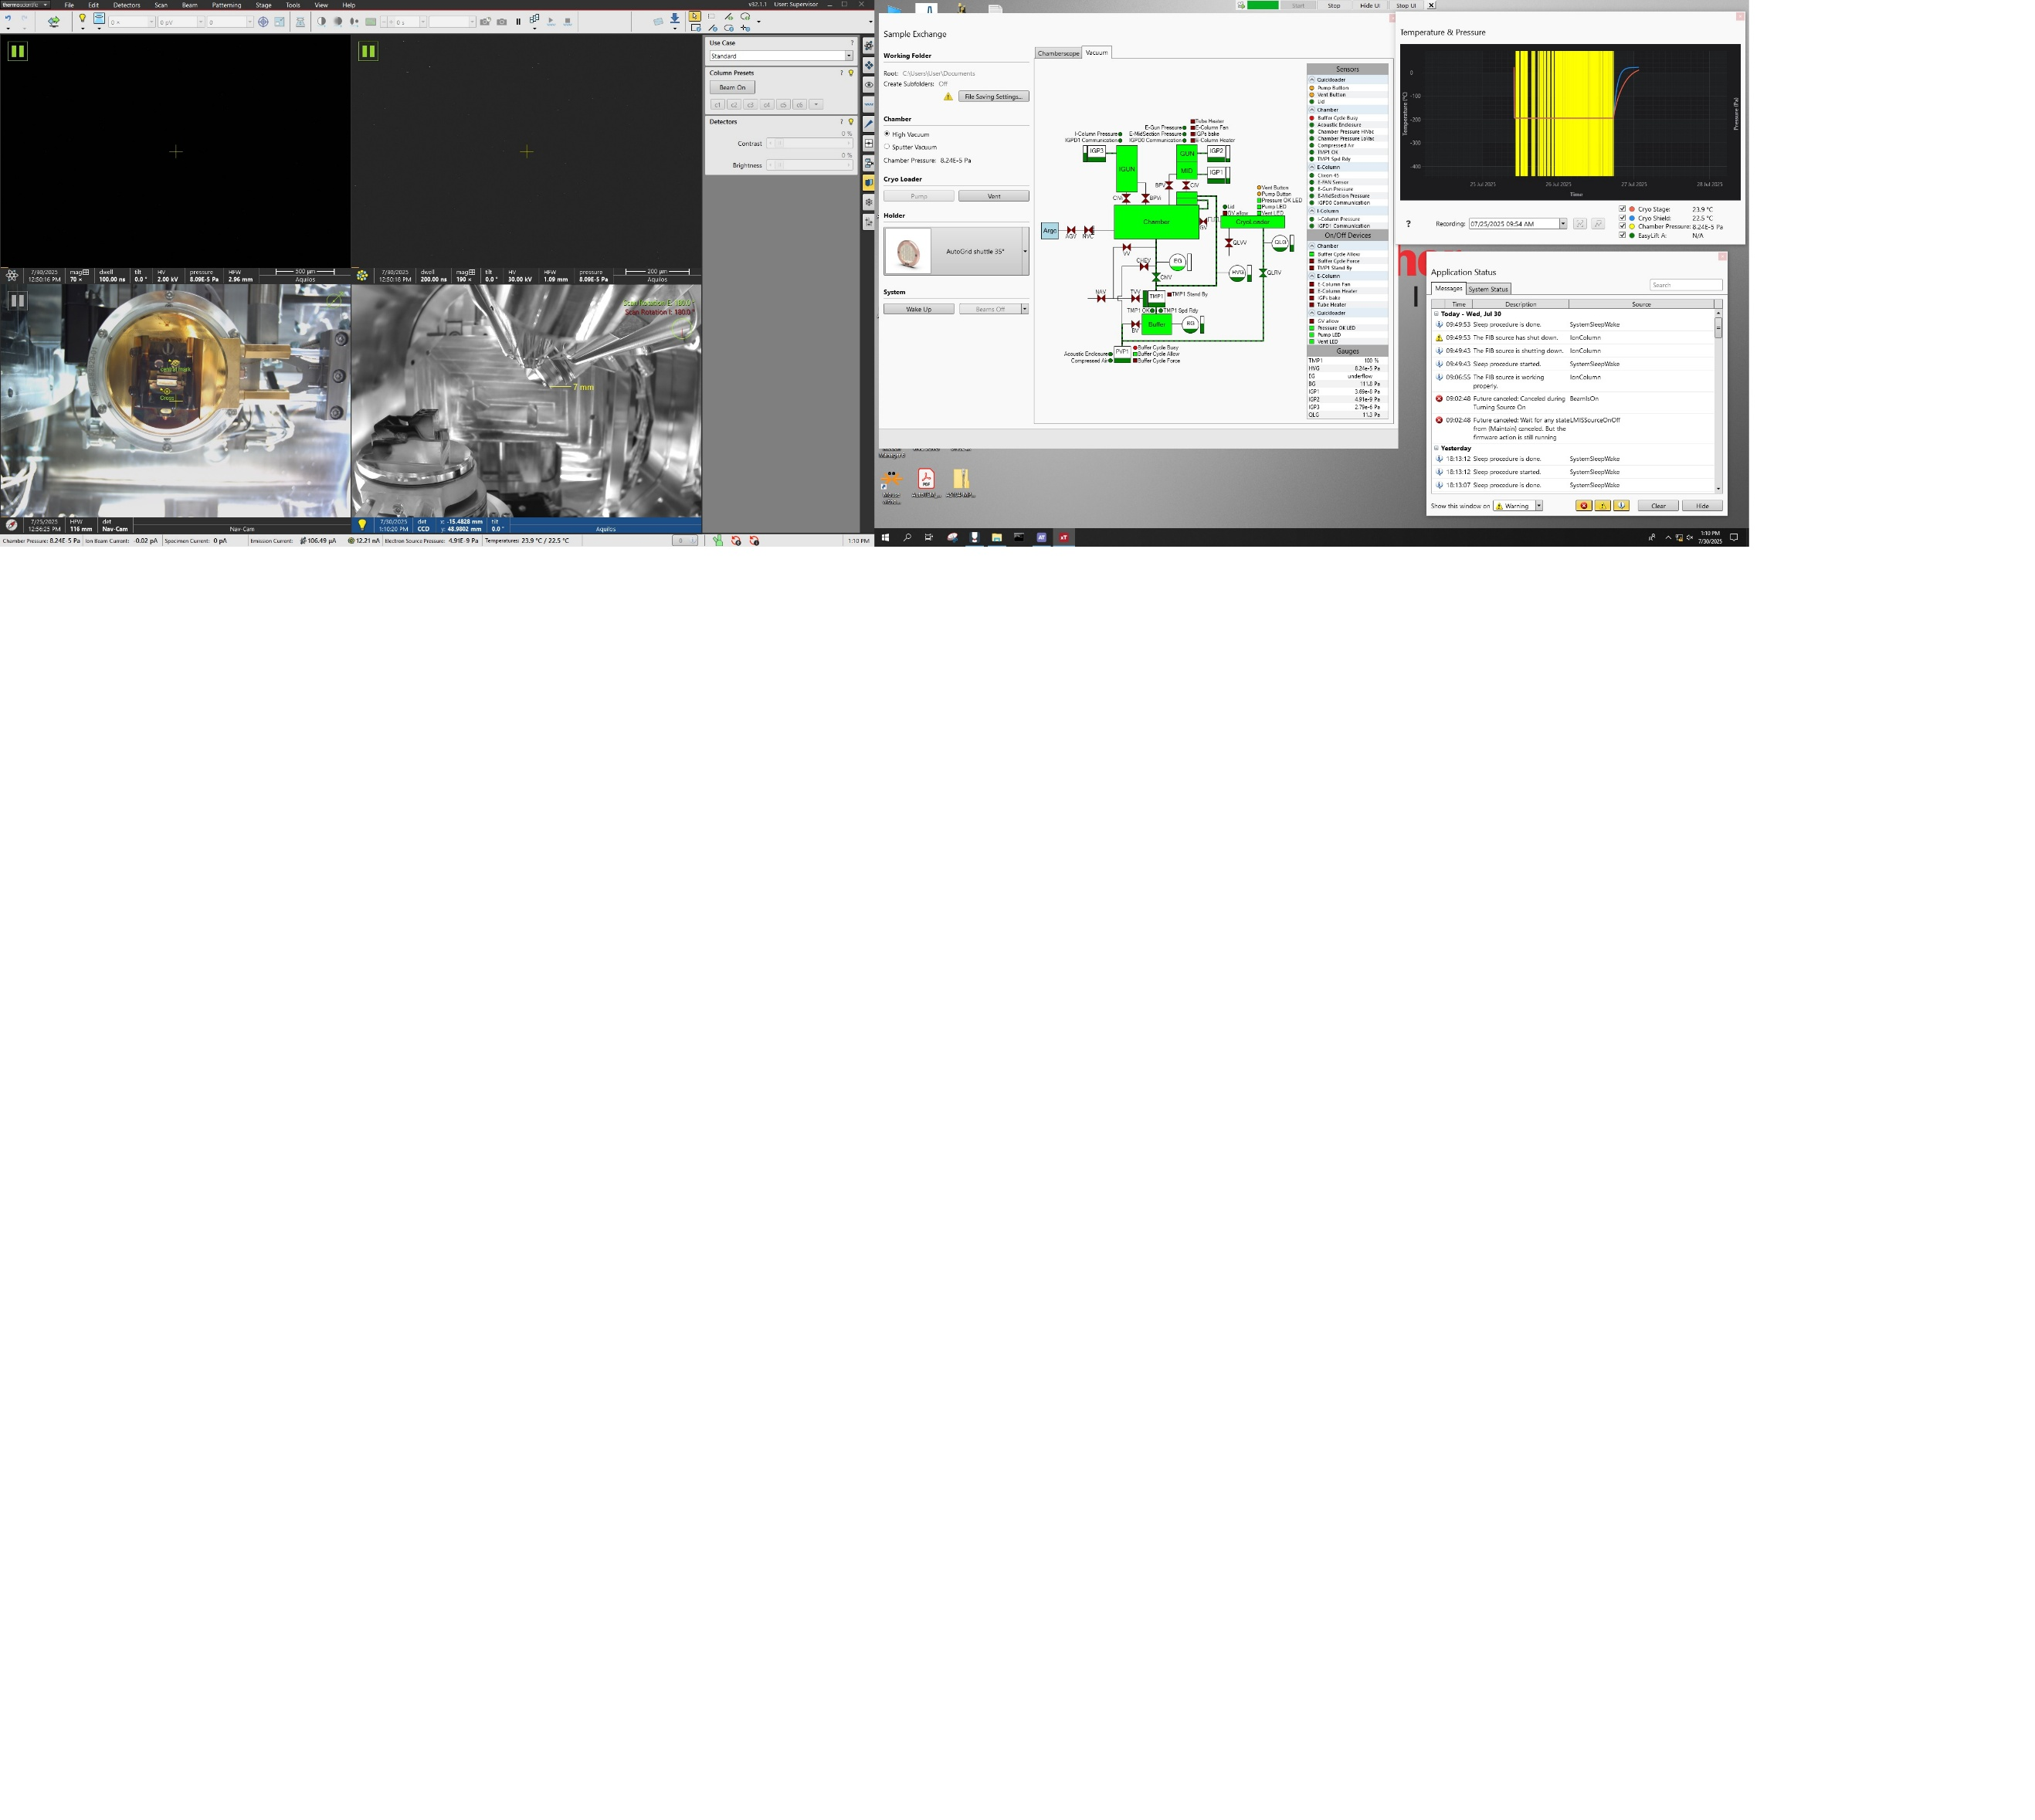
- Open vacuum diagram

- Go to “Cryo TEM preparation” tab, find the section “Sputter Coating”

- Preset #3 is currently set to 30.0mA, Pressure 10Pa, Voltage 1V, Run Time 30 seconds

- If you’re milling small/medium size cells (0-12um diameter) I would suggest using preset #3
- Larger specimens (HPF, or above 12um diameter) use the same preset #3, but I would suggest increasing the “Run Time” to 45seconds
- Click on “Prepare for Sputtering”
- DON’T CLICK ANYTHING ELSE IN THE XTUI UNTIL YOUR STAGE STOPS MOVING
- Once your stage is done moving, click on “Run”, wait for sputter coating to be done
- Once the stage retracts and stops moving from the sputter coater head, click on “Recover from Sputtering”
- DON’T CLICK ANYTHING ELSE IN THE XTUI UNTIL YOUR STAGE STOPS MOVING
- I suggest taking another E-beam overview to log the sputter coat being done
- Change flow rates back to 200 in the support PC

GIS DEPOSITION:
- Go to “Shuttle Controls” and ensure you’re in the mapping position underneath the E-beam
- Go to middle of your grid and ensure that you are in focus
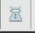
- Click “Link Z to FWD” located in top row of buttons in the XTUI

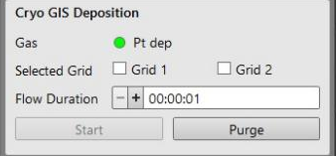
- Find the section above “Cryo GIS Deposition” in the same tab “Cryo TEM preparation”

- Check whichever grid you are working with, both checked will deposit on both grids separately
- Input “Flow Duration” of 30 seconds for smaller/medium size cells (0-12um diameter)
- For larger specimens (HPF, or above 12um diameter) input “Flow Duration” of 45-50 seconds
- Once ready to deposit GIS, click on “Start”
- Stage will move back into the previous position once done, I would suggest taking another E-beam overview to log the GIS being done
- Wake FIB up by selecting the I-beam quadrant and clicking “Beam On” under the “Column” section in the “Beam Control” tab
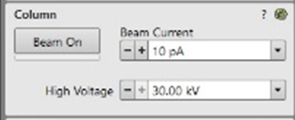
WAKE FIB UP NOW!

EUCENTRIC HEIGHT - MAPS

- Can draw measurement lines to indicate the FIB-Autogrid notch if you want
- Go to mapping position in E-beam before you start picking sites
- Once ROI is found in maps, right click and “Add Lamella Site Here” you can re-name this position in the left pane
- With a lamella site selected in the left pane, in the panel directly below this, you can perform eucentric height for each one
- Click on “Drive To” mapping position for each lamella site
- Center feature and focus in E-beam first
- In the eucentric position window that pops up in maps 3.29, change the step to 5 degrees
- Move stage down by clicking the LEFT arrow, move feature back by double clicking to center in E-beam, repeat until you come to 10 degrees for the stage tilt
- Once 10 degrees is achieved, click on “Calculate Eucentric Position” in maps 3.29
- Click on “Drive To” under the eucentric position panel
- Re-center feature under E-beam, click “Update” under eucentric position panel
- Repeat steps 128-136 for all lamella sites

COINCIDENCE POINT:
- Highlight the I-beam quadrant, ensure FIB is woken up properly by viewing the green bar underneath the “Beam On”
- Change aperture to low current (10pA-30pA) in the same section
- Click on “Beam On”
- In maps 3.29, “Drive To” eucentric height for whichever site to start with
- Do a quick scan in the I-beam to find your cell and increase magnification to 5000x
- Double click in the I-beam to center your feature in the E-beam
- Focus by using arrow keys to move the stage left/right then using (F7- Reduced Area)
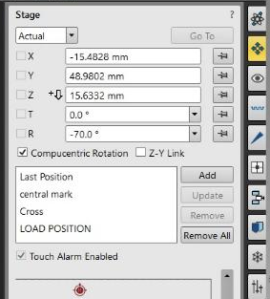
- Go to “Navigation” tab on right side in XTUI

- Find the lowest angle you can still see your feature at by tilting 2 degrees at a time down
- Once lowest angle has been found, tilt 1 degree up
- Go to E-beam, double click to center feature back up
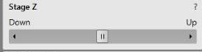
- Go back to Ion beam and compensate for the change by changing “Z” value up or down until your feature comes back into view.

- Repeat steps 77 & 78 until viewing the same feature and no adjustments need to be made
- Save this position in the “Navigation” tab by clicking “Add” in the “Stage” section, name it however you like
- Select the lamella site in maps 3.29 and click on “Store Angle” for a double save
- Repeat steps 141 – 152 for each lamella site
COARSE MILLING:
- Drive to saved navigation positions for each lamella site to do subsequent coarse milling
- With Eucentric and coincidence calculated, go to the “Patterning” tab


- Draw patterns by going to the “Patterning Control” section and click the first dropdown menu you see.

- Select “Rectangle Pattern”

- Draw one pattern over your cell, leave 200-300nm on left/right sides of cell
- Top portion of pattern (#1) should only be stretched until it covers a bit more than the top portion of the cell
- Copy the pattern by selecting the pattern then using “CTRL-C” paste it by “CTRL-V”
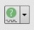
- Paste the pattern twice, deactivate #3 by going to the “Patterning Control” tab and find the icon to the right of the trash can icon

- Clicking this icon while your pattern is selected will deactivate/activate the pattern
- Checkmark indicates activation
- With your 3 patterns populated, make #2 (bottom pattern) stretch in Y to cover the bottom portion of your cell, plus a bit more
- Place pattern #3 (deactivated one) in the middle of your cell
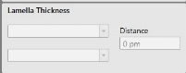
- Change the distance between patterns #1 (top) and #2 (bottom) by going to the “Lamella Thickness” section below the “Patterning Control” section, change the number to 2.5um-2um to start off

- Coarse milling very small size cells (400nm – 3um diameter) use 10pA – 50pA
- Coarse milling small size cells (3-6um diameter) use 50pA – 0.1nA
- Coarse milling medium size cells (6-15um diameter) use 0.1nA – 0.5nA
- Coarse milling larger size cells (15-30um diameter) use 0.5nA – 3.0nA
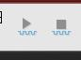
- Focus may change upon switching apertures, ensure your focus is clear before you start milling
- Once apertures/patterns are set, click on to start milling

- Pauses the IMAGE ONLY if the play button is pressed again
- To STOP the milling, click on this icon

- To be more efficient, shorten sections of patterns which contains no more material to ablate.
- Once this first step (2.5um-2um) is done, change it to 2um-1.2um for the “Lamella Thickness”
- Continue milling
- Change to 1.2um-800nm after the previous step is done
- Continue milling
- Final thickness should be 600-800nm before moving forward

Optional steps 181-182, dependent on proportions of cell

- Once your lamella is between 600-800nm, tilt 1 degree up, mill ONLY with the top pattern on the top edge of the cell
- Tilt 1 degree down, mill ONLY with the bottom pattern on the bottom edge of the cell
- Repeat steps 154-182 for all coarse milling of lamellae
POLISH MILLING:
- All your lamellae should be between the thicknesses of 400nm-700nm before you start polishing
- Use currents/apertures of 10pA – 30pA for polishing, focus very well
- Set patterns like before, covering the top and bottom portion of your lamella, shrink patterns to fit millable area
- Change the “Lamella Thickness” to 600nm
- Mill until material is ablated away, change “Lamella Thickness” to 500nm
- Keep reducing “Lamella Thickness” by 100nm until 300nm, then by 50nm to 200nm
- Target lamella thickness should be below 200nm for your entire lamella.
- Repeat steps 184-190 for all polishing
CLEAN UP:
- Drive to mapping position & take final images of lamella in E-beam & I-beam post milling
- Sputter coat using preset #2 if needed. (Optional)
- Go to “Beam Control” tab, under “System” section, dropdown menu, click on “Sleep”
- Get fresh liquid nitrogen, unload samples
- Save samples to dedicated lamella dewar in Aquilos 2+ room
- Place shuttle back inside of the Aquilos chamber
- Empty the prep-pot in styrofoam container
- Turn off prep-pot nitrogen gas (small tank)
- In “FlowView” support PC, turn down flow rates to “0”
- Close “FlowView” by clicking “Exit” in bottom right
- Close “FlowDDE” by going to (File>Exit)
- Remove heat exchanger from large liquid dewar
- Turn off nitrogen gas in closet outside
- Go to “Cryo TEM preparation” tab, find the section “Temperature & Pressure” ensure that it is in fact your milling session
- Click on “Export” save to C:/Users/User/Documents/Aquilos2+_temp_log
- Turn off lights & leave!

