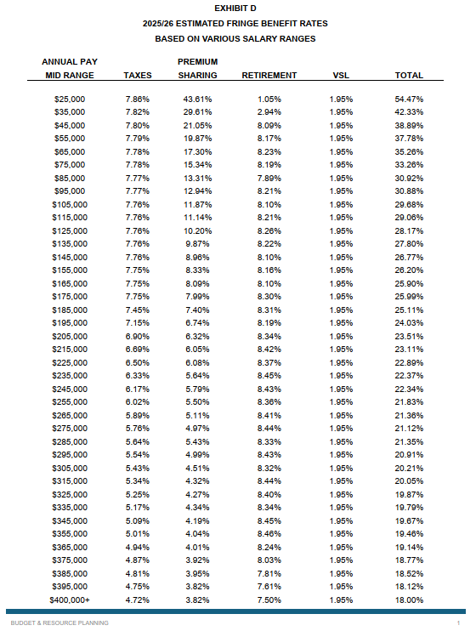
Exhibit D
Estimated Fringe Benefit Rates for Fiscal Year 2026
Based on Various Salary Ranges
Following is a list of Annual Pay Mid-Range salaries, each with specific taxes, premium sharing, retirement, vacation/sick leave assessment (or VSL), and the total percentage rate. There are 39 salary ranges listed, starting with $25,000 and ending with $400,000 or more:
#1: $25,000 salary has taxes of 7.86%, premium sharing of 43.61%, retirement of 1.05%, VSL of 1.95%, for a total of 54.47%.
#2: $35,000 salary has taxes of 7.82%, premium sharing of 29.61%, retirement of 2.94%, VSL of 1.95%, for a total of 42.33%.
#3: $45,000 salary has taxes of 7.80%, premium sharing of 21.05%, retirement of 8.09%, VSL of 1.95%, for a total of 38.89%.
#4: $55,000 salary has taxes of 7.79%, premium sharing of 19.87%, retirement of 8.17%, VSL of 1.95%, for a total of 37.78%.
#5: $65,000 salary has taxes of 7.78%, premium sharing of 17.30%, retirement of 8.23%, VSL of 1.95%, for a total of 35.26%.
#6: $75,000 salary has taxes of 7.78%, premium sharing of 15.34%, retirement of 8.19%, VSL of 1.95%, for a total of 33.26%.
#7: $85,000 salary has taxes of 7.77%, premium sharing of 13.31%, retirement of 7.89%, VSL of 1.95%, for a total of 30.92%.
#8: $95,000 salary has taxes of 7.77%, premium sharing of 12.94%, retirement of 8.21%, VSL of 1.95%, for a total of 30.88%.
#9: $105,000 salary has taxes of 7.76%, premium sharing of 11.87%, retirement of 8.10%, VSL of 1.95%, for a total of 29.68%.
#10: $115,000 salary has taxes of 7.76%, premium sharing of 11.14%, retirement of 8.21%, VSL of 1.95%, for a total of 29.06%.
#11: $125,000 salary has taxes of 7.76%, premium sharing of 10.20%, retirement of 8.26%, VSL of 1.95%, for a total of 28.17%.
#12: $135,000 salary has taxes of 7.76%, premium sharing of 9.87%, retirement of 8.22%, VSL of 1.95%, for a total of 27.80%.
#13: $145,000 salary has taxes of 7.76%, premium sharing of 8.96%, retirement of 8.10%, VSL of 1.95%, for a total of 26.77%.
#14: $155,000 salary has taxes of 7.75%, premium sharing of 8.33%, retirement of 8.16%, VSL of 1.95%, for a total of 26.20%.
#15: $165,000 salary has taxes of 7.75%, premium sharing of 8.09%, retirement of 8.10%, VSL of 1.95%, for a total of 25.90%.
#16: $175,000 salary has taxes of 7.75%, premium sharing of 7.99%, retirement of 8.30%, VSL of 1.95%, for a total of 25.99%.
#17: $185,000 salary has taxes of 7.45%, premium sharing of 7.40%, retirement of 8.31%, VSL of 1.95%, for a total of 25.11%.
#18: $195,000 salary has taxes of 7.15%, premium sharing of 6.74%, retirement of 8.19%, VSL of 1.95%, for a total of 24.03%.
#19: $205,000 salary has taxes of 6.90%, premium sharing of 6.32%, retirement of 8.34%, VSL of 1.95%, for a total of 23.51%.
#20: $215,000 salary has taxes of 6.69%, premium sharing of 6.05%, retirement of 8.42%, VSL of 1.95%, for a total of 23.11%.
#21: $225,000 salary has taxes of 6.50%, premium sharing of 6.08%, retirement of 8.37%, VSL of 1.95%, for a total of 22.89%.
#22: $235,000 salary has taxes of 6.33%, premium sharing of 5.64%, retirement of 8.45%, VSL of 1.95%, for a total of 22.37%.
#23: $245,000 salary has taxes of 6.17%, premium sharing of 5.79%, retirement of 8.43%, VSL of 1.95%, for a total of 22.34%.
#24: $255,000 salary has taxes of 6.02%, premium sharing of 5.50%, retirement of 8.36%, VSL of 1.95%, for a total of 21.83%.
#25: $265,000 salary has taxes of 5.89%, premium sharing of 5.11%, retirement of 8.41%, VSL of 1.95%, for a total of 21.36%.
#26: $275,000 salary has taxes of 5.76%, premium sharing of 4.97%, retirement of 8.44%, VSL of 1.95%, for a total of 21.12%.
#27: $285,000 salary has taxes of 5.64%, premium sharing of 5.43%, retirement of 8.33%, VSL of 1.95%, for a total of 21.35%.
#28: $295,000 salary has taxes of 5.54%, premium sharing of 4.99%, retirement of 8.43%, VSL of 1.95%, for a total of 20.91%.
#29: $305,000 salary has taxes of 5.43%, premium sharing of 4.51%, retirement of 8.32%, VSL of 1.95%, for a total of 20.21%.
#30: $315,000 salary has taxes of 5.34%, premium sharing of 4.32%, retirement of 8.44%, VSL of 1.95%, for a total of 20.05%.
#31: $325,000 salary has taxes of 5.25%, premium sharing of 4.27%, retirement of 8.40%, VSL of 1.95%, for a total of 19.87%.
#32: $335,000 salary has taxes of 5.17%, premium sharing of 4.34%, retirement of 8.34%, VSL of 1.95%, for a total of 19.79%.
#33: $345,000 salary has taxes of 5.09%, premium sharing of 4.19%, retirement of 8.45%, VSL of 1.95%, for a total of 19.67%.
#34: $355,000 salary has taxes of 5.01%, premium sharing of 4.04%, retirement of 8.46%, VSL of 1.95%, for a total of 19.46%.
#35: $365,000 salary has taxes of 4.94%, premium sharing of 4.01%, retirement of 8.24%, VSL of 1.95%, for a total of 19.14%.
#36: $375,000 salary has taxes of 4.87%, premium sharing of 3.92%, retirement of 8.03%, VSL of 1.95%, for a total of 18.77%.
#37: $385,000 salary has taxes of 4.81%, premium sharing of 3.95%, retirement of 7.81%, VSL of 1.95%, for a total of 18.52%.
#38: $395,000 salary has taxes of 4.75%, premium sharing of 3.82%, retirement of 7.61%, VSL of 1.95%, for a total of 18.12%.
#39: $400,000+ salary has taxes of 4.72%, premium sharing of 3.82%, retirement of 7.50%, VSL of 1.95%, for a total of 18.00%.

